## 0/24Using GNS3 Software

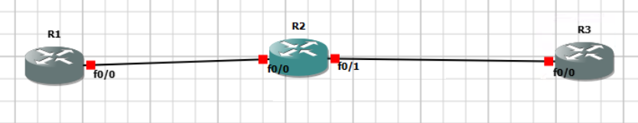

Create a Topology as shown above

Use Cisco 3735 as a router image.

Start the Devices and double click to launch the CLI

**To Run the CLI**

There the 3 modes available on CLI

1. User Executable Mode (R1>)
2. Privileged Mode (R1#)
3. Global Configuration mode (R1(config)#)

r1# CONFIGURE TERMINAL

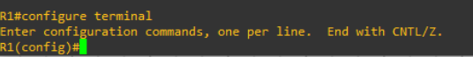

The privileged mode is used for commands like copy, ping, traacert, debug.

The Global Configuration mode is used to Configure the device.

From user mode R1> enable

From Privileged Mode (R1# configure terminal)

To come back

From the Global Configuration Mode type “exit” and from the Privileged Mode “ disable”.

Press “?” to see all the commands supporting the particular Mode.

Use “Tab” Key to complete a Command.

Use a Question mark with space to view the options of a command.

To Set the enable Password

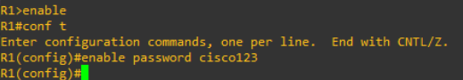

To configure the secret password

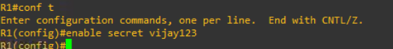

To view the Running Configuration File

R1# show running-config

To copy the Configuration from RAM to NVRAM

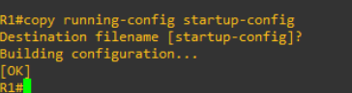

—-----------------------------------------------------------------------------------------------------------------

## Date: 22/07/2024

## Configuring Layer 2 Switches

To Check the Version of IOS

#Show version

To Configure hostname

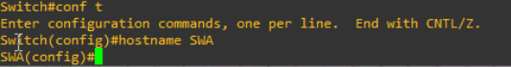

To Copy the configurations from RAM to NVRAM

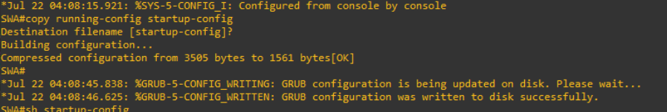

(OR)

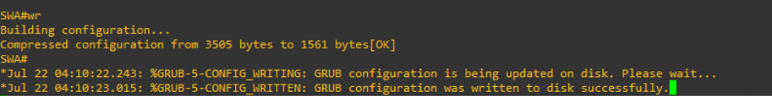

To View the mac address table

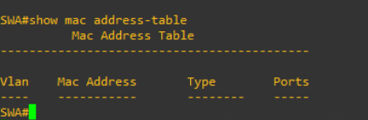

## To Configure VLANs

Create a topology in the packet tracer

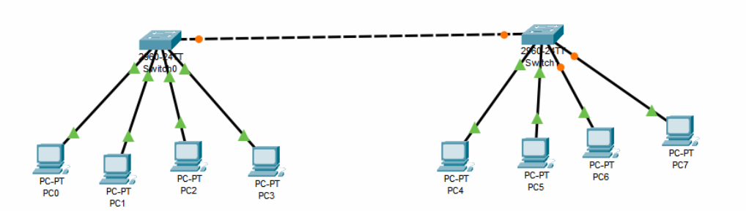

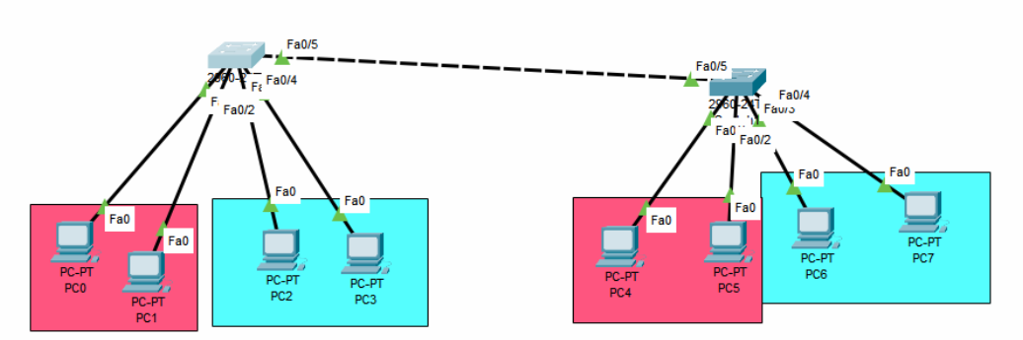

On Switch 0

To open the console of Switch, double click and Click CLI

To create VLANs

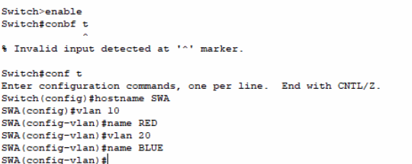

On the Switch1, Repeat the same configuration

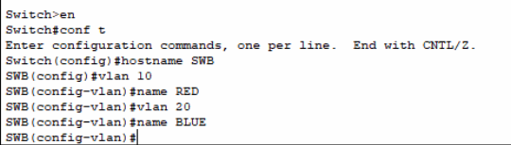

To make the port labels visible

Go to Options > Preferences

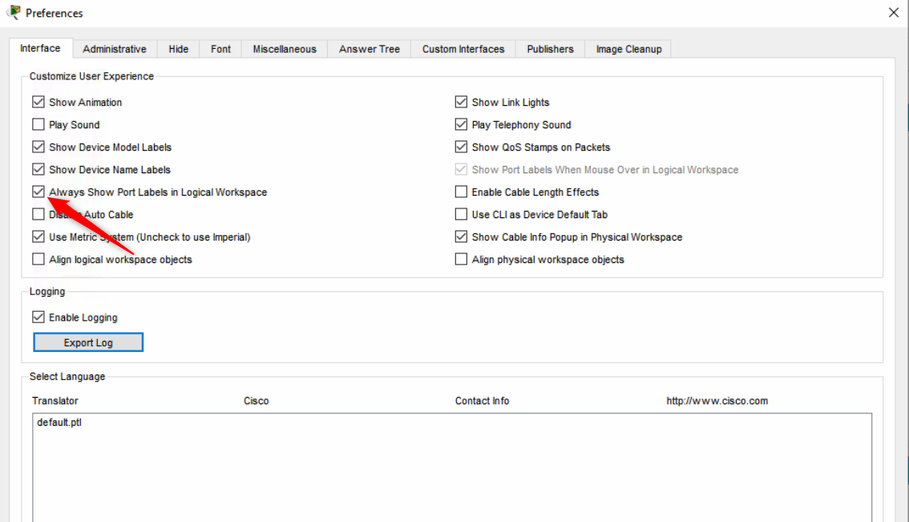

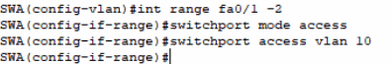

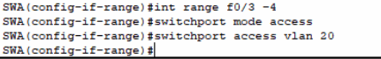

On SWB

Repeat the same configuration.

To verify the VLAN configuration

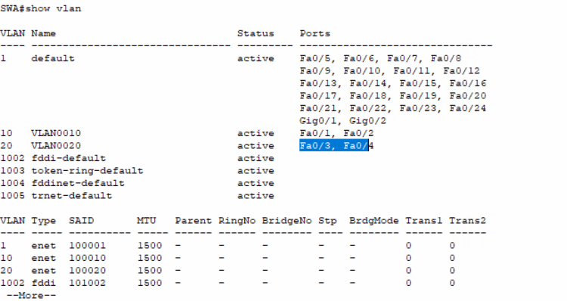

To configure the IP add

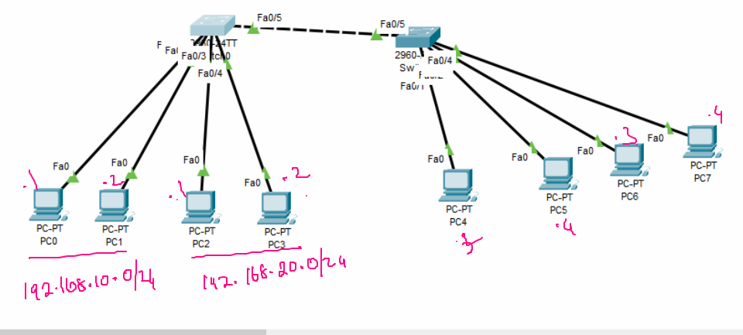

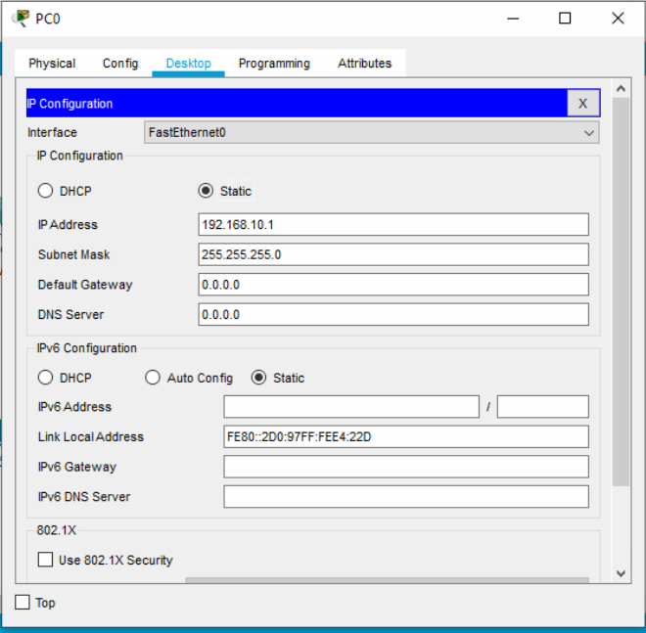

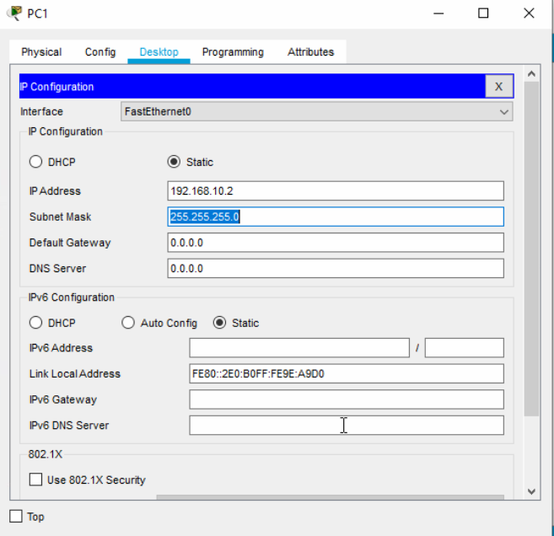

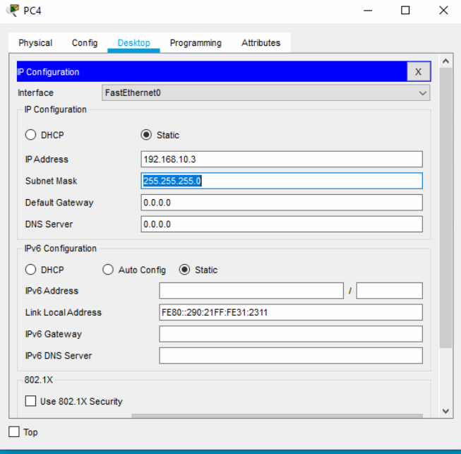

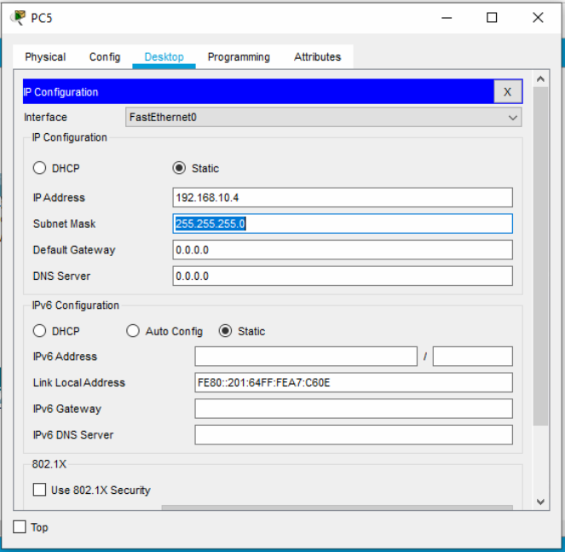

For PCs Connected to VLAN 20

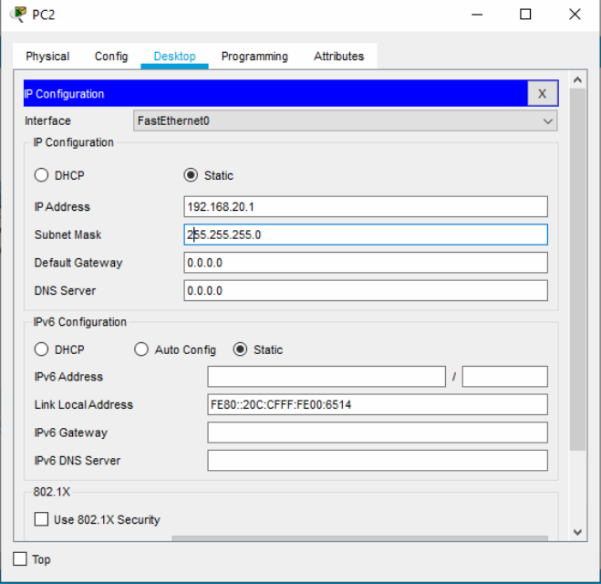

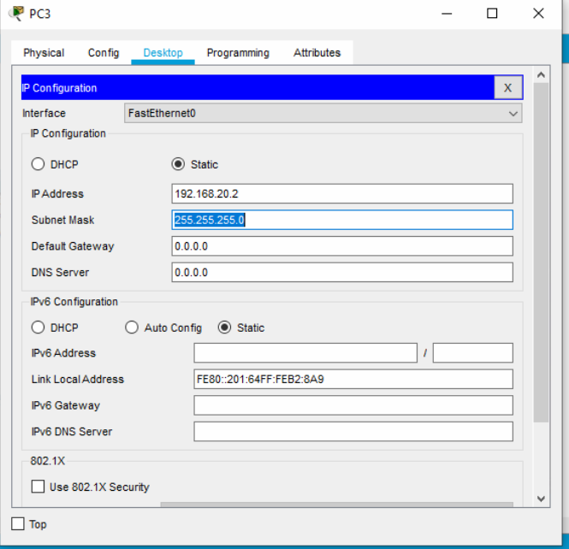

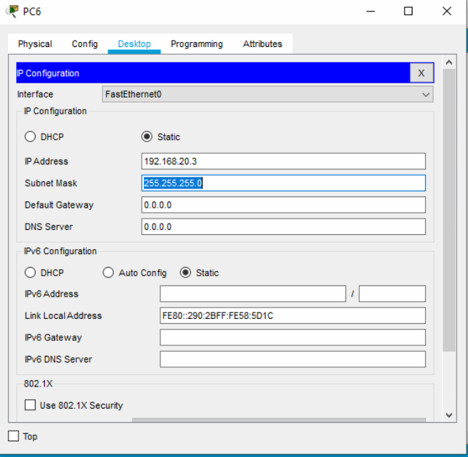

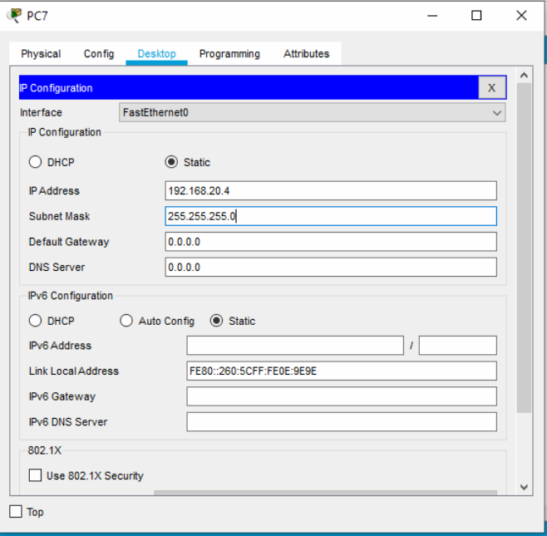

To configure trunk port

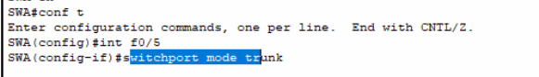

On SWB

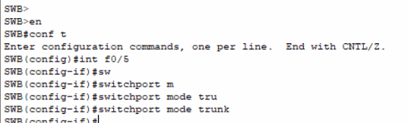

to Verify USe Ping Command.

You should be able to ping to PCs under the same VLAN but not to PCs under a different VLAN.

### Date : 23/07/2024

## Configuring InterVLAN Routing

Step 1: Create VLAN Database

Step 2: Ports connected to the PCs should be associated to respective VLANs and the port should be in Access Mode.

Step 3: Port connected to the Router should be configured as a trunk port with 802.1q protocol enabled ( Which is the default).

Step 4: The routers interface will not accept the command “Switchport”

The router's interface should be enabled

And You have to create a Sub-interface. ( Logical Interface) ( Duplicate interface).

And make the logical interface to accept the dot1q protocol

On the subinterface enable dot1q protocol and associate the VLAN that the subinterface is subjected to carry and then configure a IP address to the subinterface.

Step 5: Configure IP address for the PC and Associate the default gateway( The Default gateway should be IP address of reszpective Subinterface caring the VLAN traffic.)

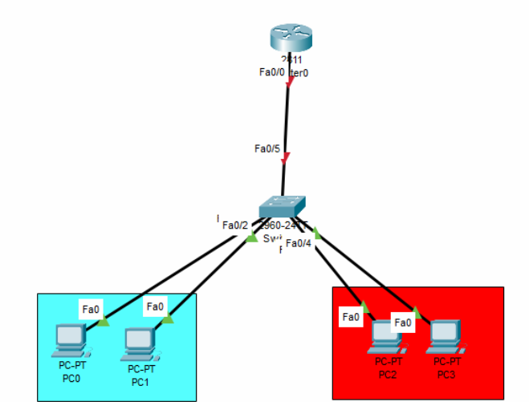

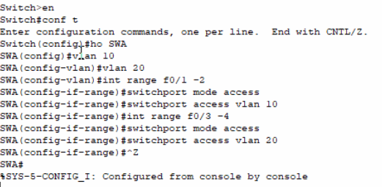

The next step is to enable f0/5 as a trunk port.

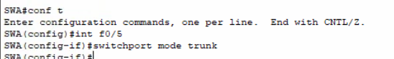

To Verify the Access ports show vlan

Enable the routers interface

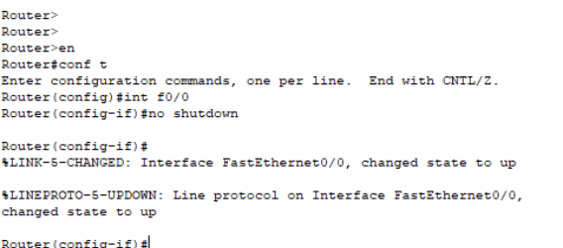

To verify if the trunk is configured correctly

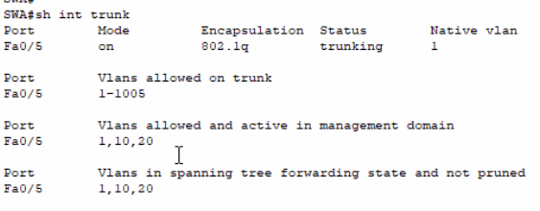

On the Router on the Interface connected to the Switch, Create subinterface and enable dot1q, associate VLAN and Configure a IP address.

The IP address of f0/0.10 should be 192.168.10.100

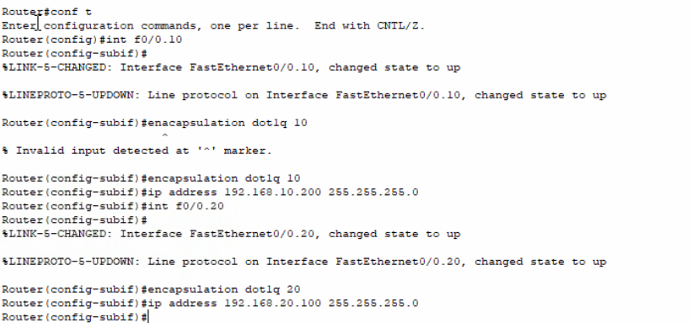

Configure IP and default gateway for the PCs

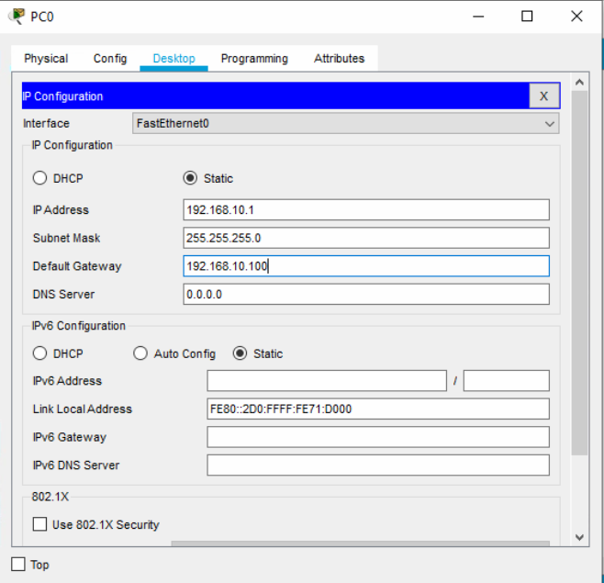

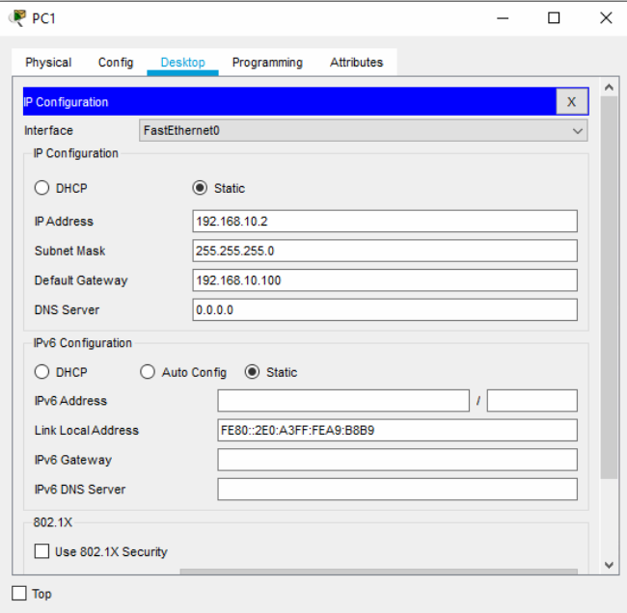

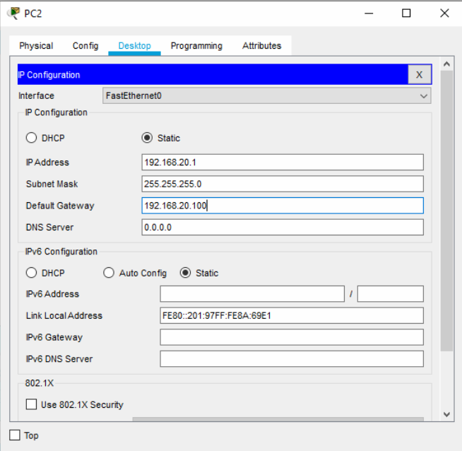

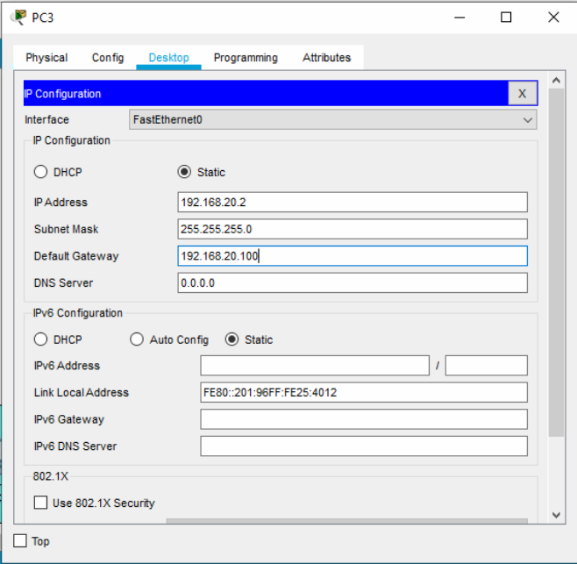

## Configuring InterVLAN Communication with Layer 3 Switches - SVI

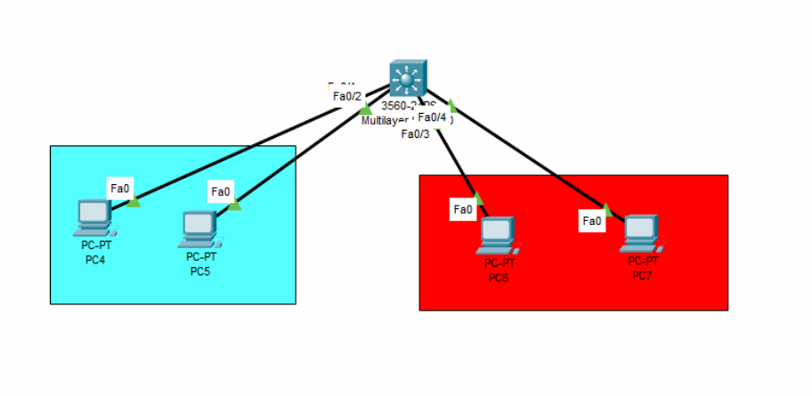

On the Layer 3 Switch

1. Create VLAN database and Associate the port into respective VLANs

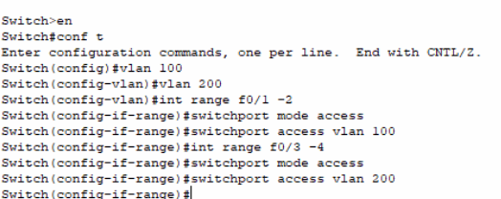

Create a Logical interface for each and every VLAN and Configure a IP address to the Logical interface. This logical interface is called the SVI

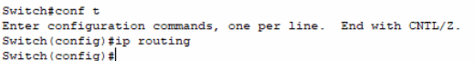

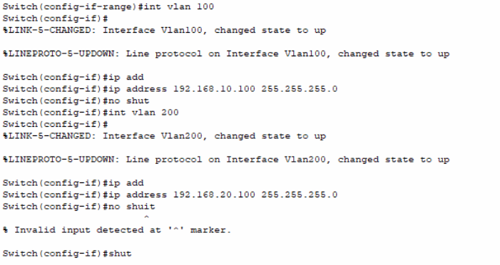

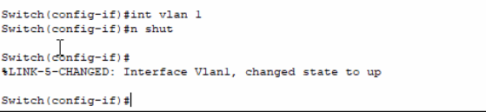

Configure Ip address and default gateway of the PCs

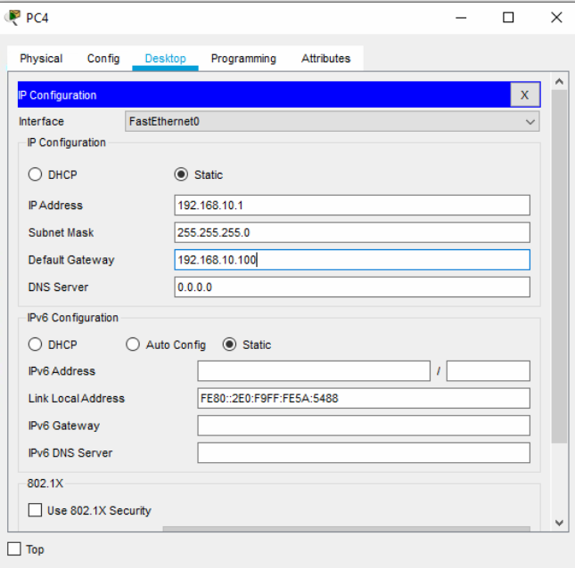

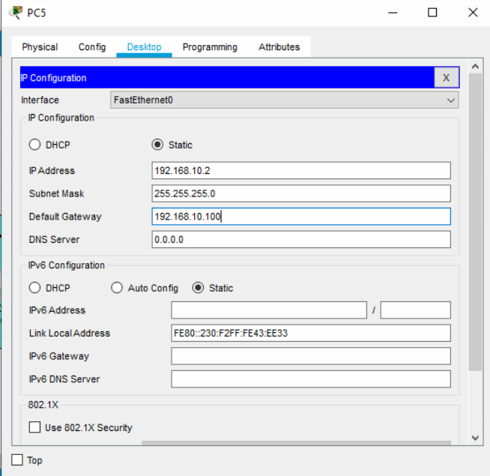

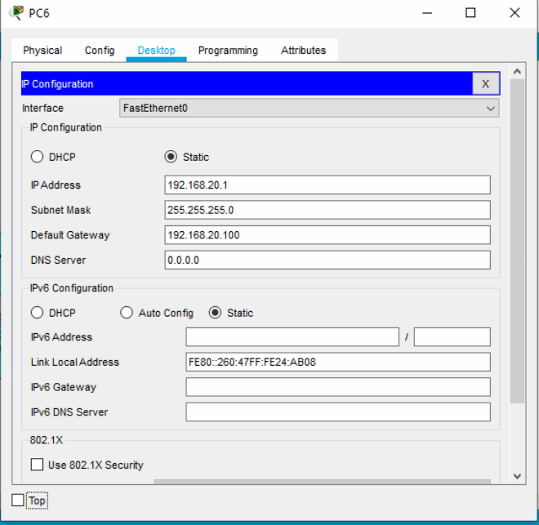

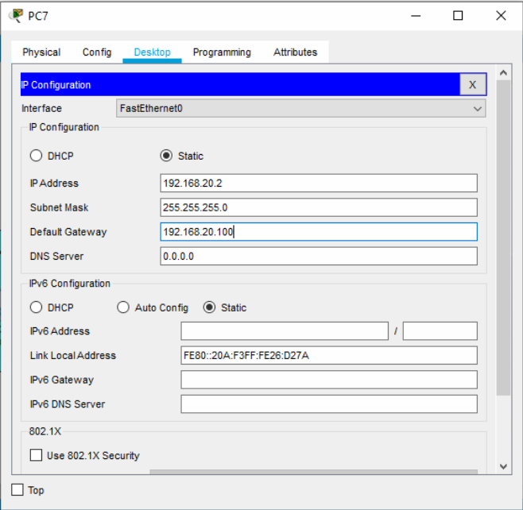

## Configuring VTP

Topology

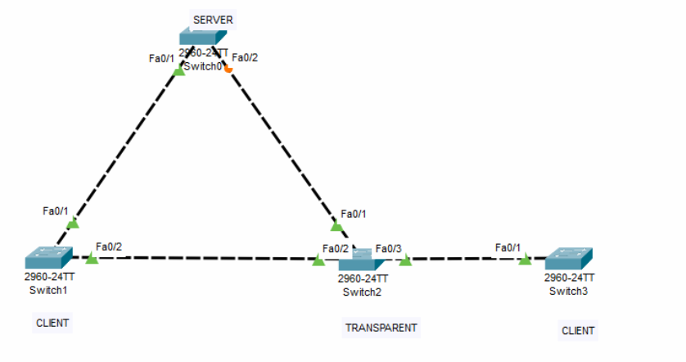

Step : All the Ports connected between the Switches should in Trunk mode

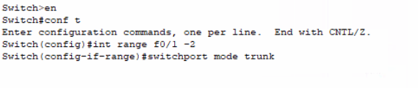

Do this on all the switches

On Sw0

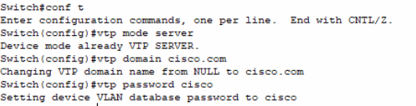

On SW1

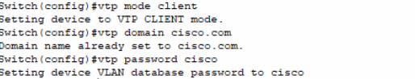

On SW2

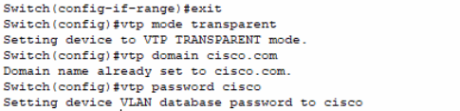

On SW3

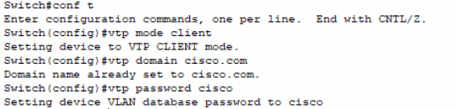

We will create vlans on the server and we check if client and transparent is copying the database.

Check the working of VTP with show vtp status command.

## Configuring Port Channel

Topology

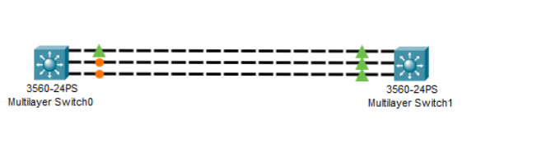

First We will configure trunk on All the interfaces ( Where the trunk is mandatory for the Ether channel) On L3 Swiches

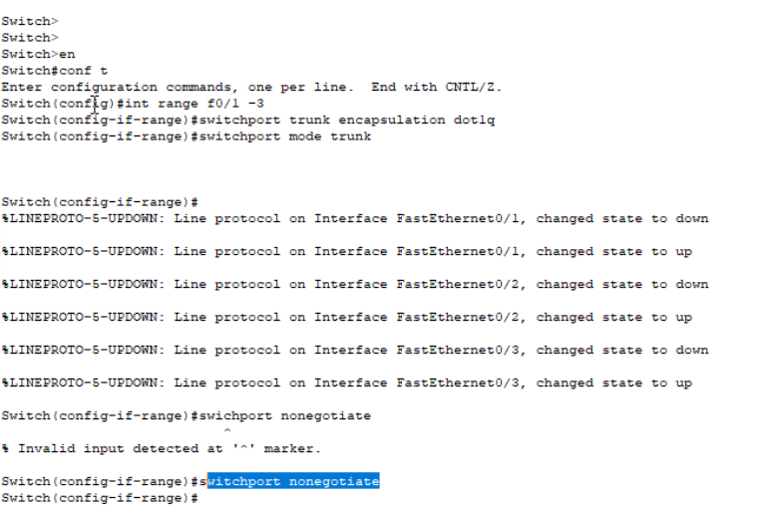

ON SW1

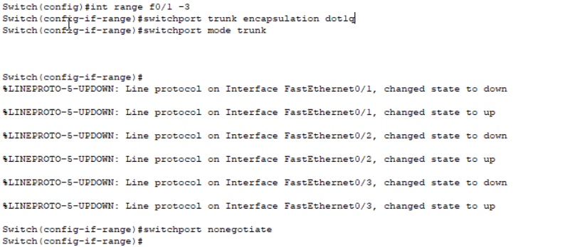

To Make the Ether Channel

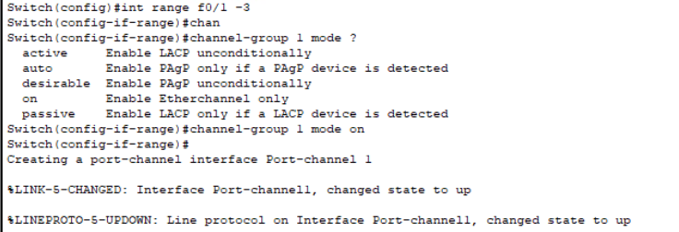

On Sw1

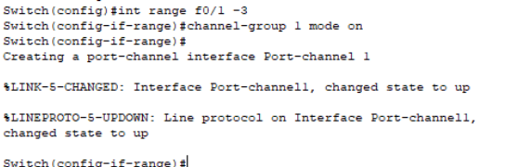

To make a port channel into Layer 3

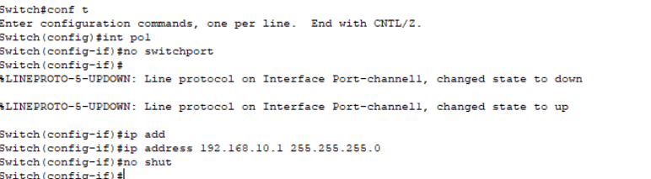

Task

1. Create a Port-channel with PAGP and Make it L3
2. Create a Port Channel with LACP and Make it L2

## Configuring Default Gateway Redundancy (HSRP)

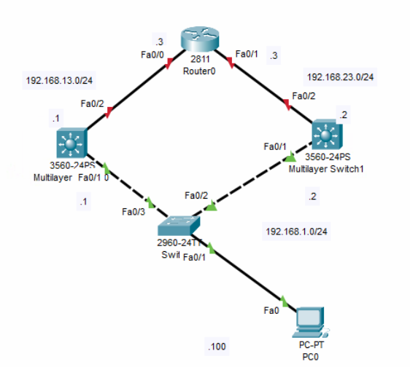

First , we will configure the IP address on all devices

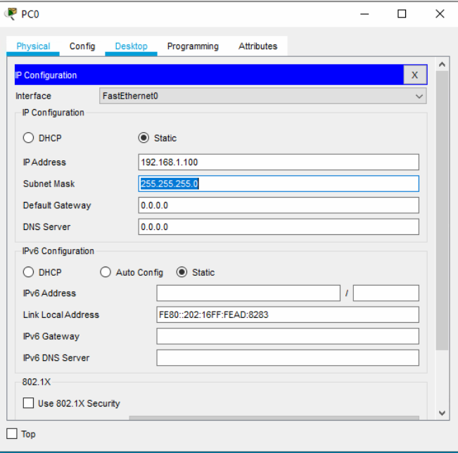

On SW0

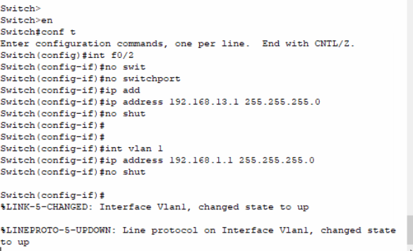

On SW1

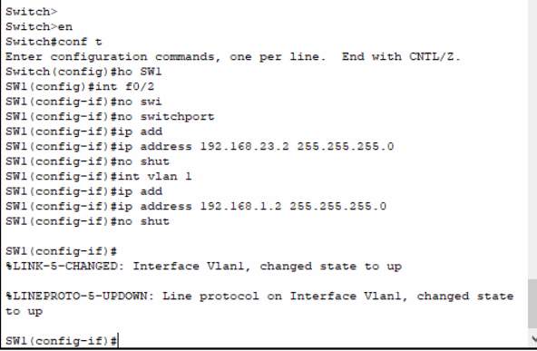

On the Router

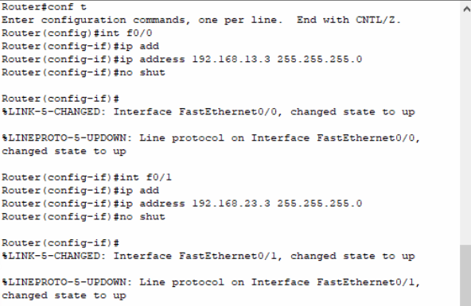

Now., We have to enable HSRP on both SW0 and SW1 the virtual IP is 192.168.1.254

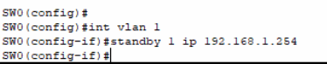

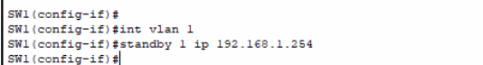

Finally configure the Virtual IP as a default gateway on the PC

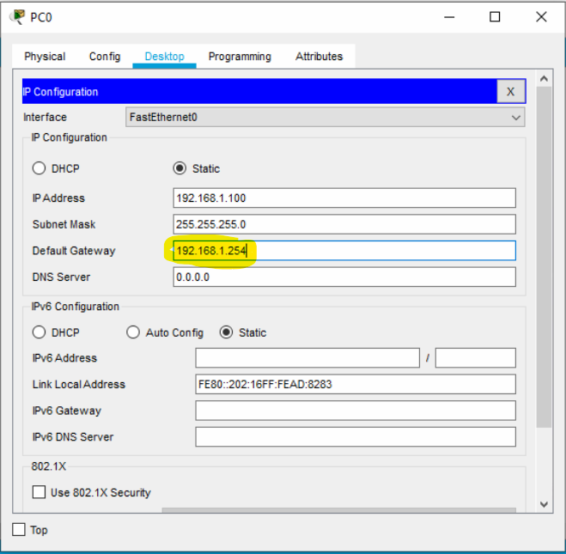

Verify the ping

Ping to 192.168.1.254

To verify the status of the HSRP use “ show standby”

In order to make a device ACTIVE configure the priority. The device with high priority is the ACTIVE

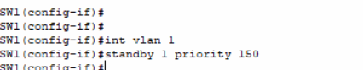

# Routing Technologies

## Configuring Static Routing

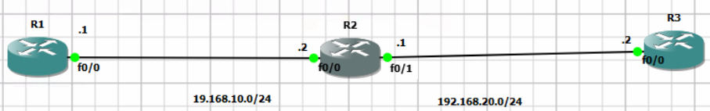

First, Configure IP address on all the interfaces

Int <Interface Name>

Ip address <IP > < Subnet Mask>

No shutdown

Syntax

Ip route < Destination Network Address> < Subnet Mask> < Next hop IP address or Name of Exit Interface>

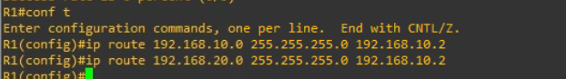

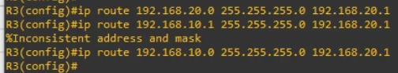

Remember, No static route is required to directly connected interfaces/routers

Verify the static route with Ping

To View the Routing table “ Show IP ROUTE”.

## Exercise 2 - Static Routing

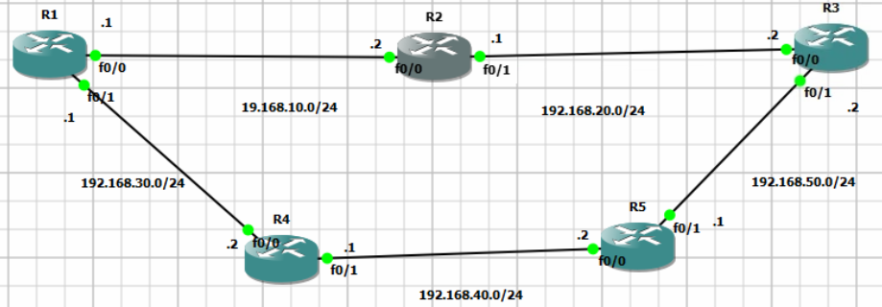

Implement a Floating Static Route to force R1 to use R4 and R5 to reach R3.

## Configuring Default Route

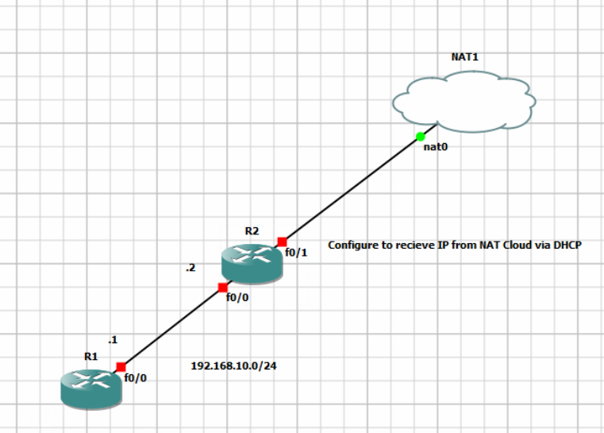

Configure IP address on R1

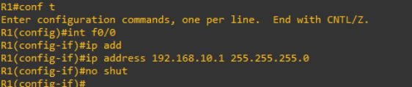

For R2

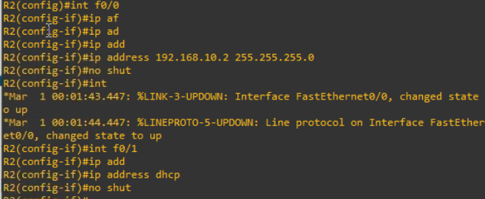

On R1



On R2

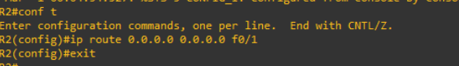

## Configuring RIP

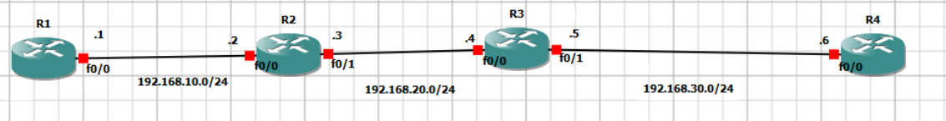

First, Configure IP address on all devices and interfaces

Enable RIP on the interfaces

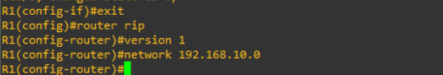

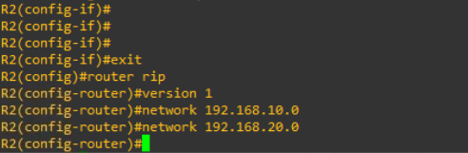

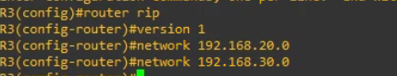

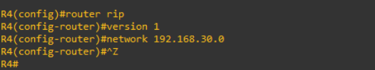

To view the Routing t able

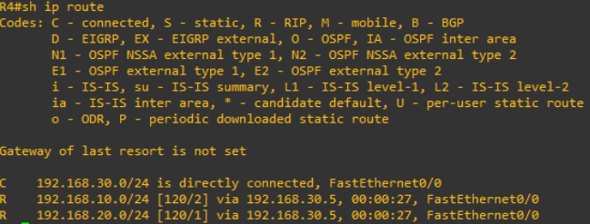

To view the Entire protocol configuration

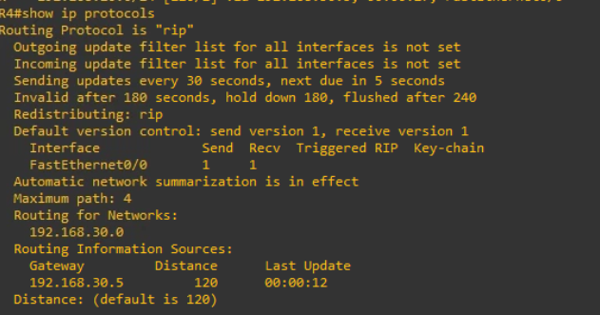

To view the rip database

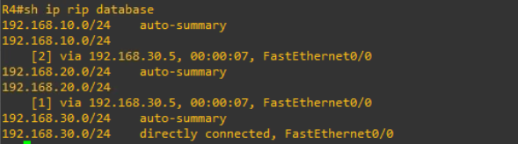

To Enable Version 2

Router rip

Version 2

No auo-summary

## Configuring RIP Version 2 and Disabling auto Summarization

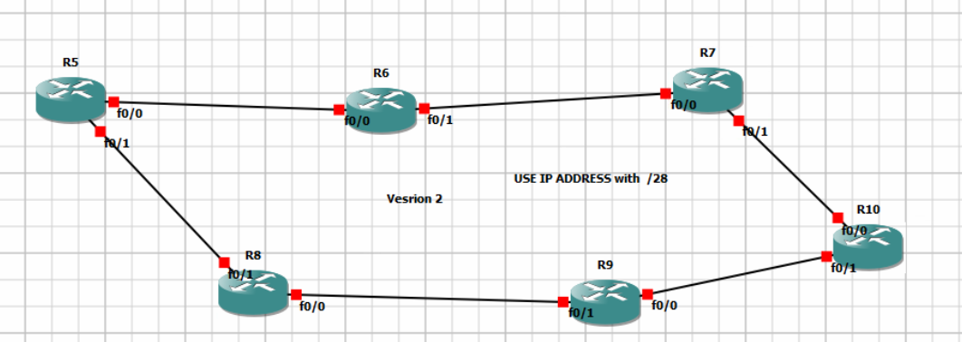

## 

## Configuring OSPF



After setting up IP address on the devices

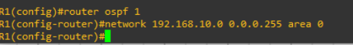

## Configuring BGP

### 

### Lab 1: Basic BGP

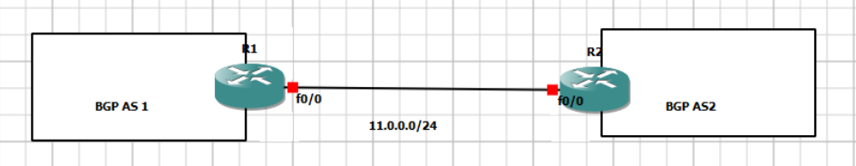

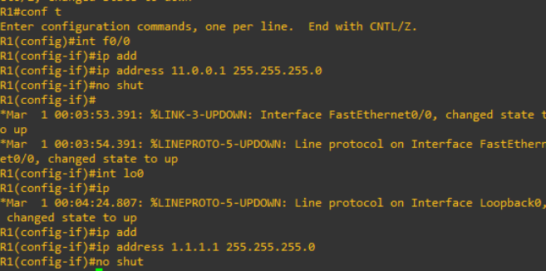

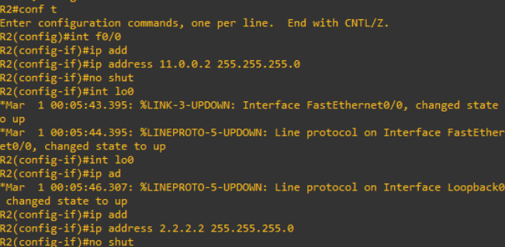

We have just configured the IP address for f0/0 and the loopback interface for both routers.to enable BGP (eBGP) on R1



Now, configure BGP on R2

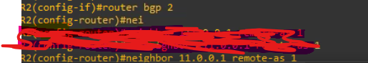

To view the neighbor relationship of BGP use “show ip bgp summary”

To include the loopback interfaces to communicate Configure the loopback with iBGP

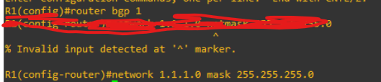



To view the routing of BGP “ show ip bgp”

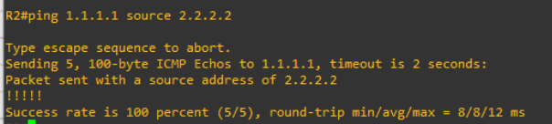

Configuring BGP with iBGP

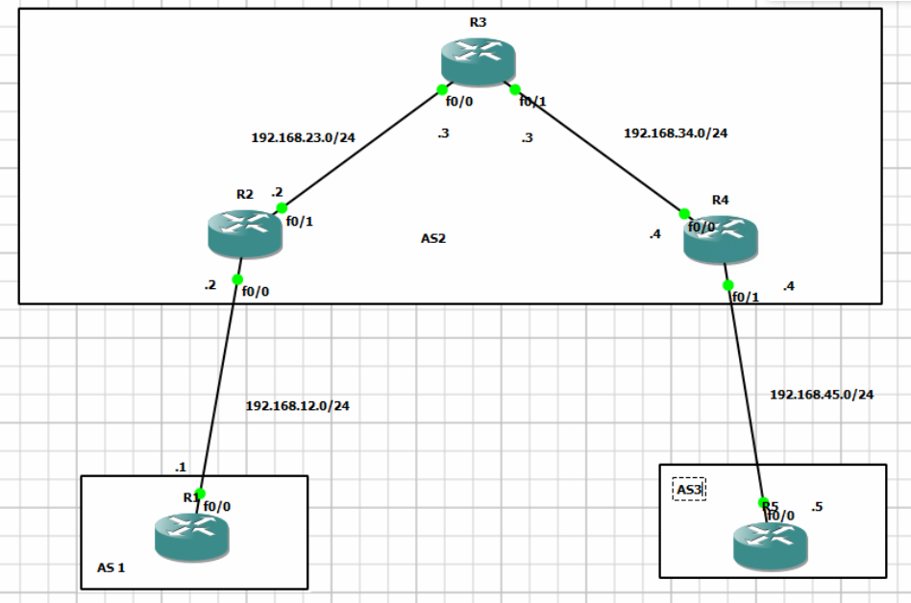

Configure IP address on all interfaces

Configure Loopback interface on R1

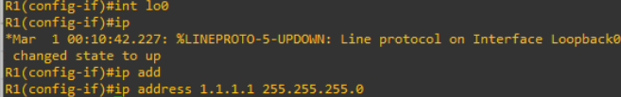

Configure BGP on R1

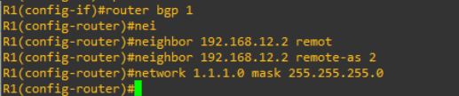

Configure EBGP between R2 and R1

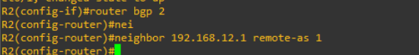

Configure Lo0 on R2 and R4

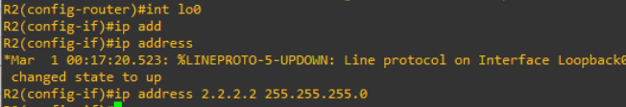

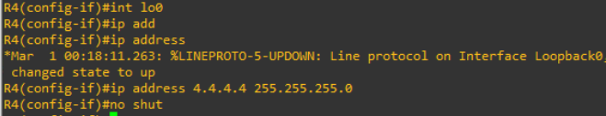

Configure OSPF between R2, R3 and R4

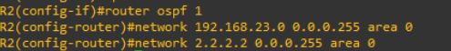

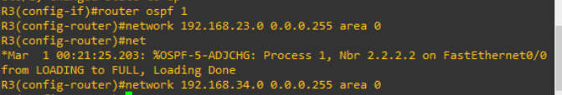

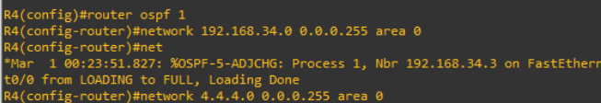

now , We will verify the communication between R2 and R4

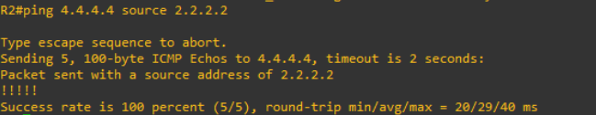

Let us configure IBGP between R2 and R4

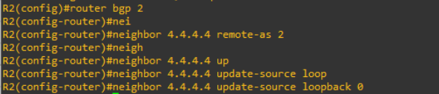

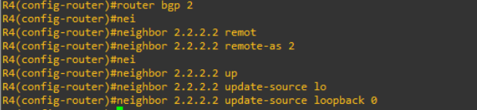

Enable ebgp between R4 and R5

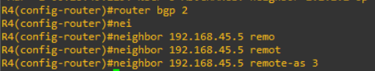

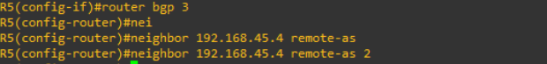

If R2 wants to reach lo0 interface of R1 it says that it will use 192.168.12.1 ( f0/0 interface of R1).

If R4 wants to reach lo0 interface of R1 it also says that i will use 192.168.12.1 but R4 does not have any path to reach 192.168.12.1

Solution

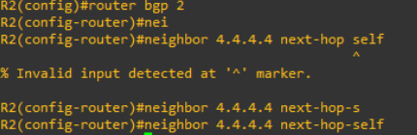

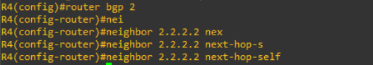

## Configuring Passwords for Line Modes

To configure Console password and Auxillary password

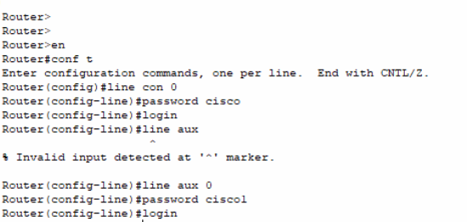

## Configuring Telnet and SSH

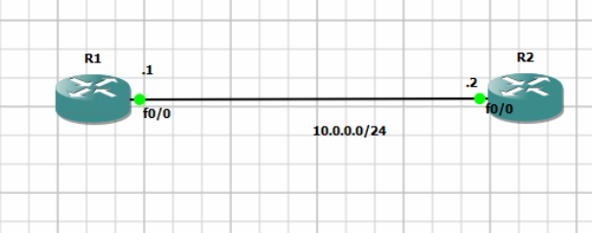

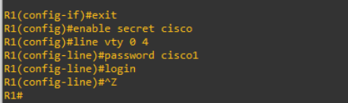

To configure SSH

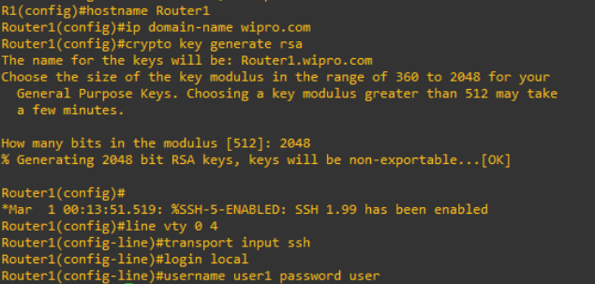

## Configuring DHCP

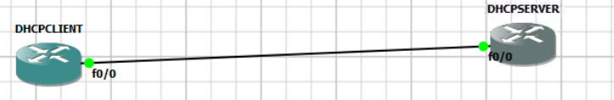

On the DHCP SERVER

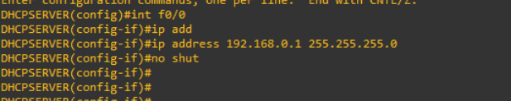

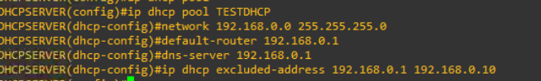

Access the Client Device and

Int f0/0

Ip address dhcp

No shut

Wait for 10 secs for the server o assign the ip address to the client

## Configuring DHCP RELAY AGENT

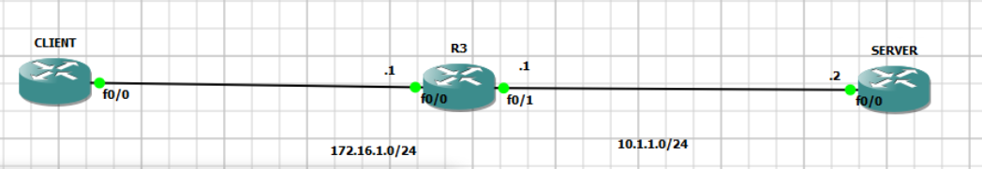

On R3

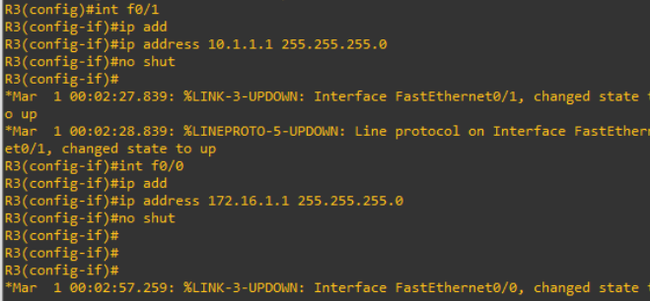

To configure the DHCP Server

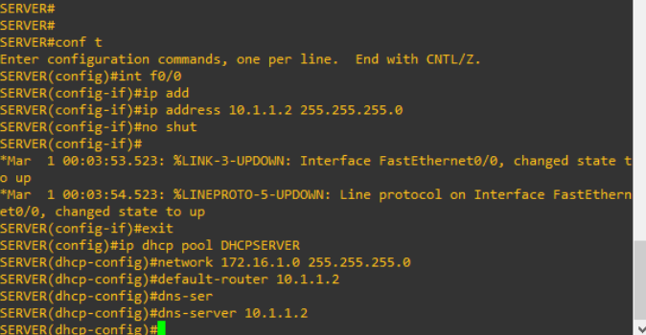

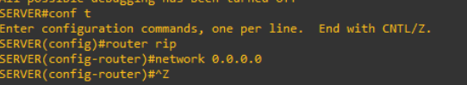

Configure Relay Agent

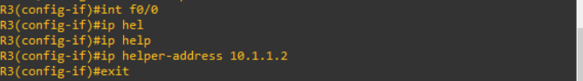

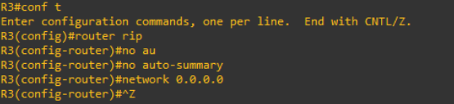

Configure the Client to receive DHCP

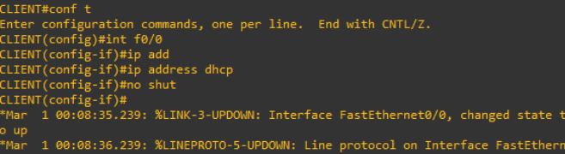

To verify the IP address Allocation on the DHCP Server use “ show ip dhcp binding”

## Configuring TFTP

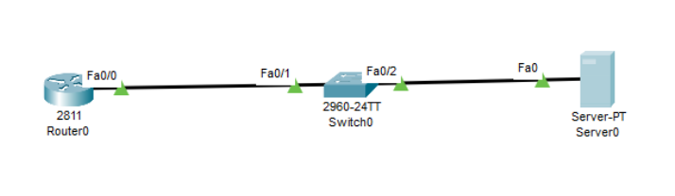

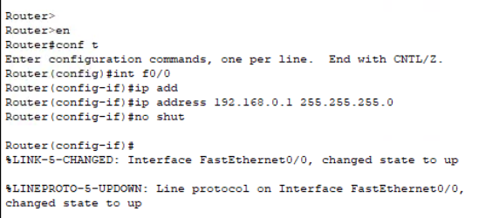

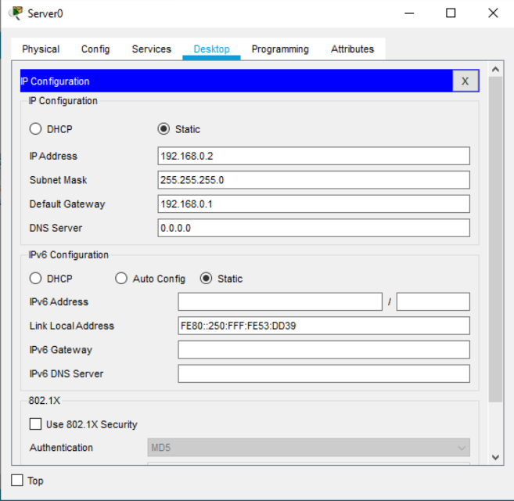

To enable TFTP on Server

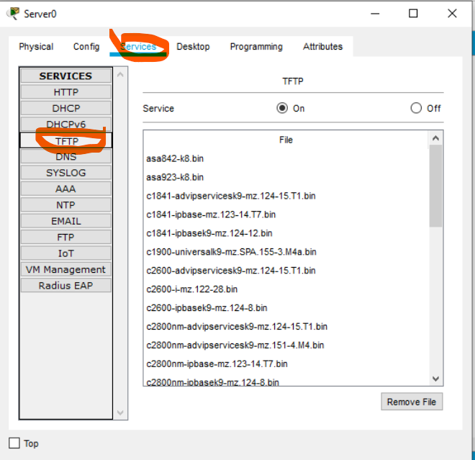

On the router

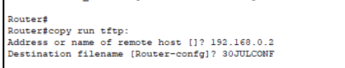

On the TFTP Server the configuration is available

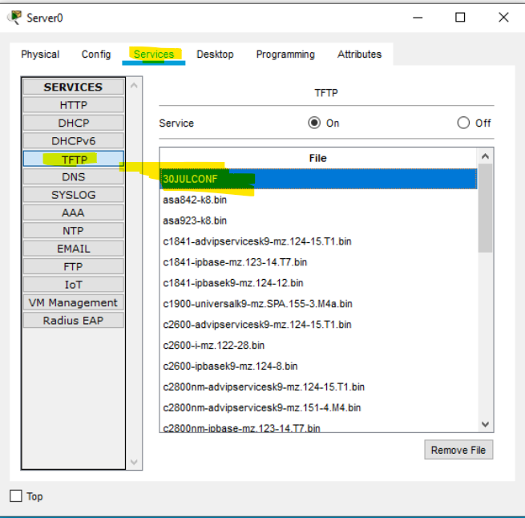

## Configuring Port Security

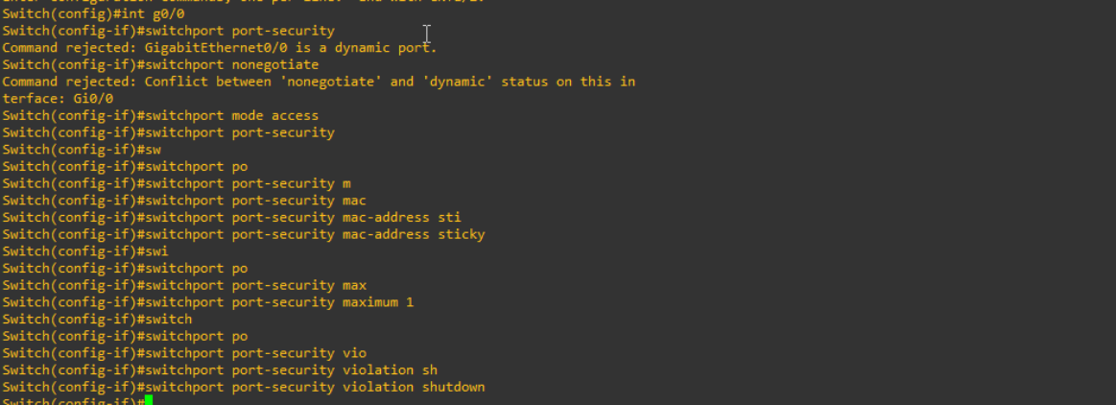

## Configuring Stanard ACLs

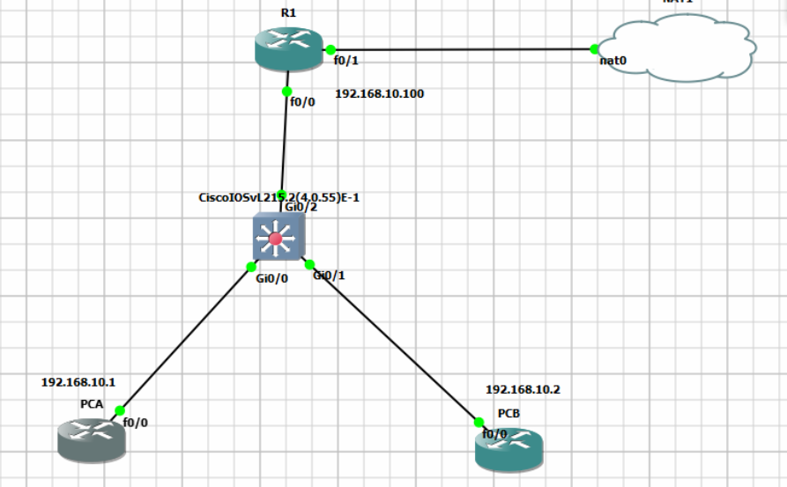

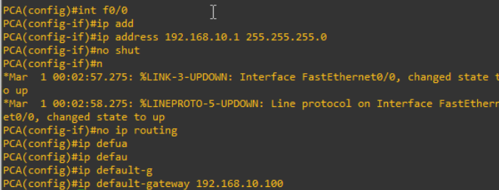

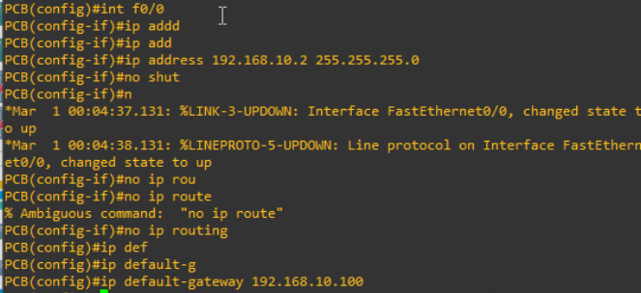

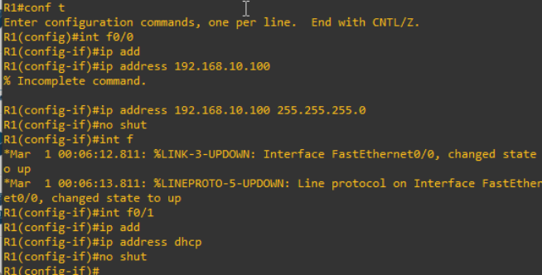

Now, Let us configure ACLs to block traffic from PCB accessing the internet

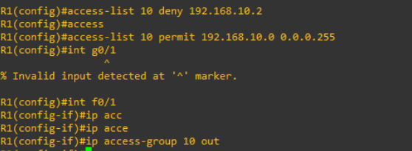

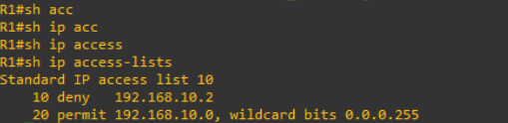

Create a Default Route on R1

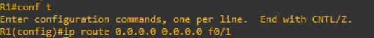

## Creating Local Database for User Authentication

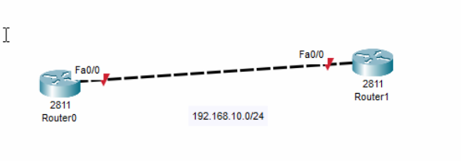

Configure the IP address

Enable AAA New Model

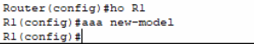

Create a user database



Create an authentication policy.



Apply the authentication policy to the VTY and Console lines

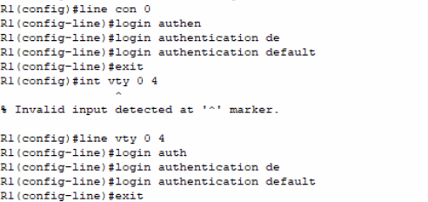

Configure Privillages to the Users

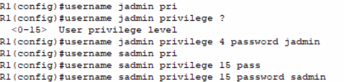

Set a Secret password.



Test by doing a telnet

## Troubleshooting Basic IPv4 Network Connectivity

To find the route the source is using to reach the destination.

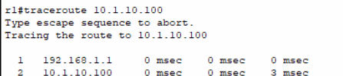

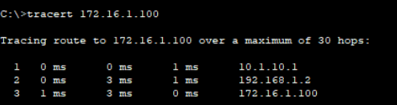

To Check the Physical Connectivity

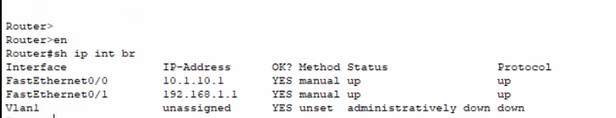

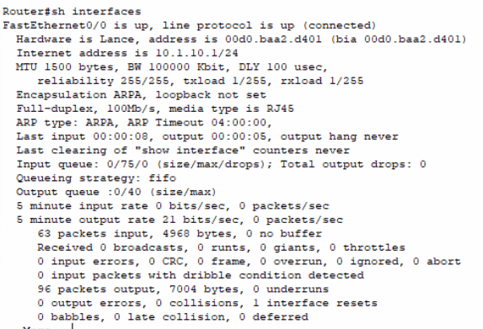

To Verify the Route

Sh ip route

Based on the Routing Protocol you have configured, Verify the Neighbour table, topology table and the Routing table.

Sh ip protocols

Sh ip rip database

Show ip ospf neighbours

Show ip ospf database

Sh ip opsf interfaces.

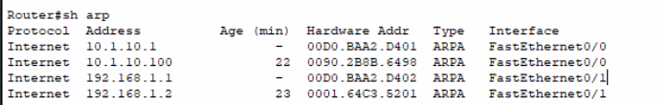

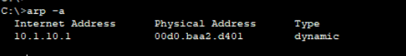

## Configuring PPP

.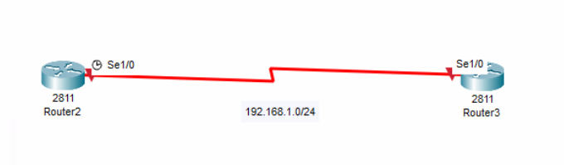

On R3

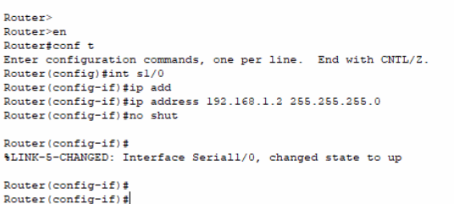

On R2

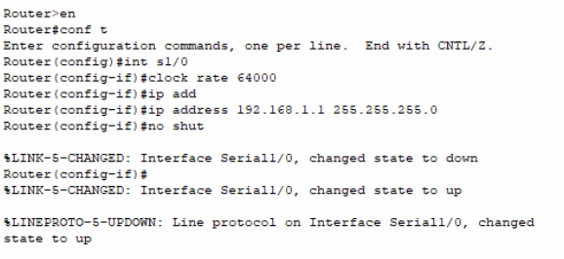

On R2

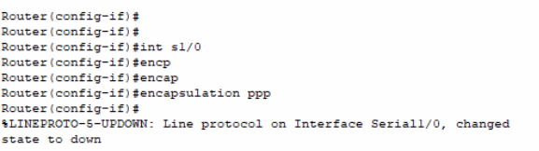

On R3

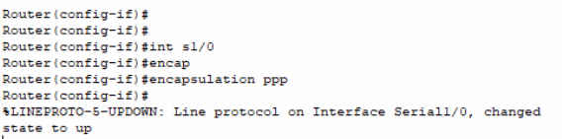

On both the routes

